Learning Outcome 3

1. The below image illustrates image binding.

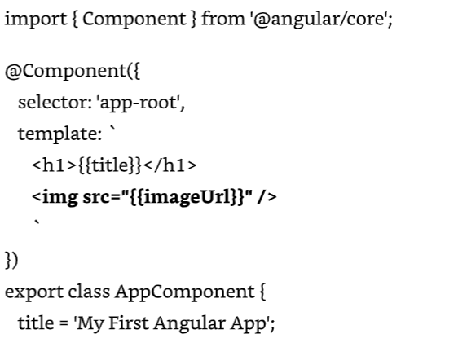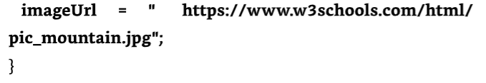

1. <link rel="stylesheet" href="https://maxcdn.bootstrapcdn.com/bootstrap/3.3.7/css/bootstrap.min.css">